**MALARIA DATASET**

**DATASET VISUALIZATION :**

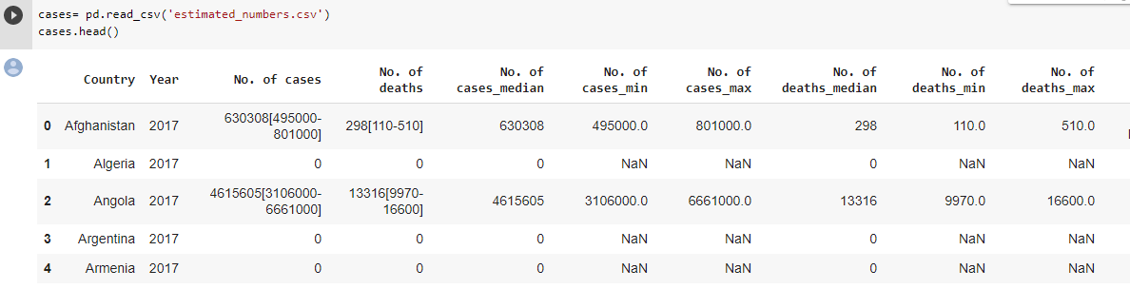

**INCIDENCE_PER_1000_POP_AT_RISK DATASET :**

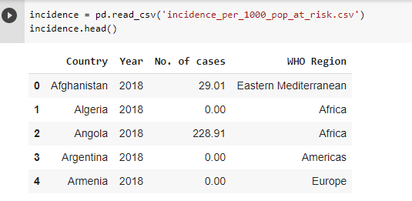

**REPORTED_NUMBERS DATASET :**

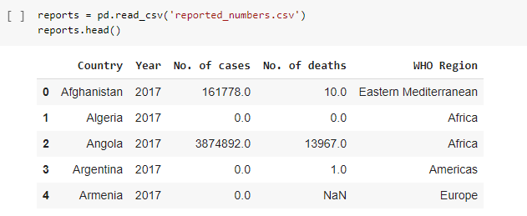

**DATA PRE-INFORMATION :**

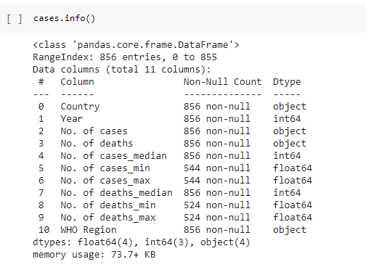

**VISUALIZATION OF NO.OF CASES IN 2016 :**



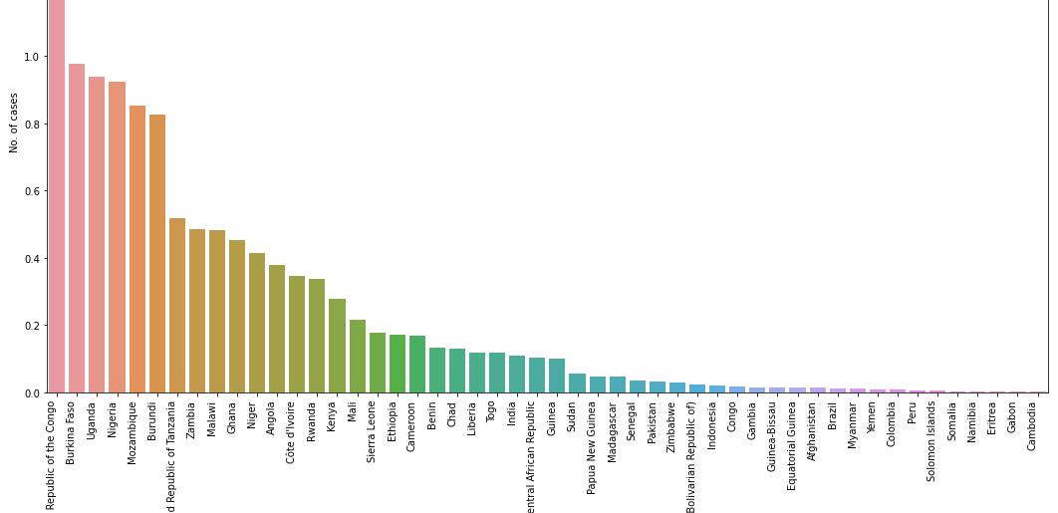

**Relationship between number of cases and number of deaths reported :**

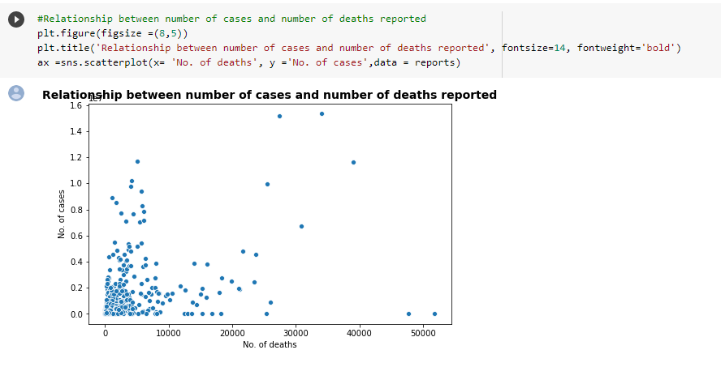

**MALARIA DEATH AND CASES OVER THE YEAR :**

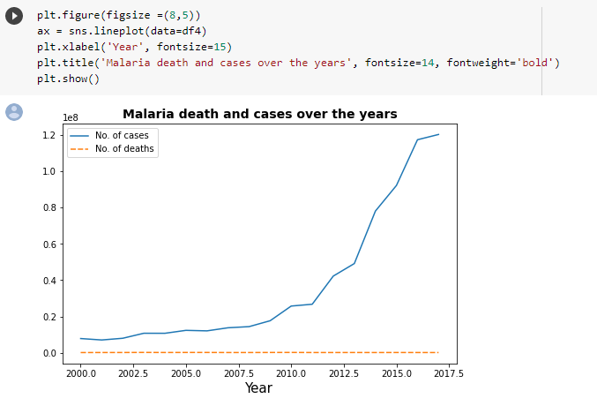

**MALARIA DEATH AND CASES IN PARTICULAR WHO REGION :**

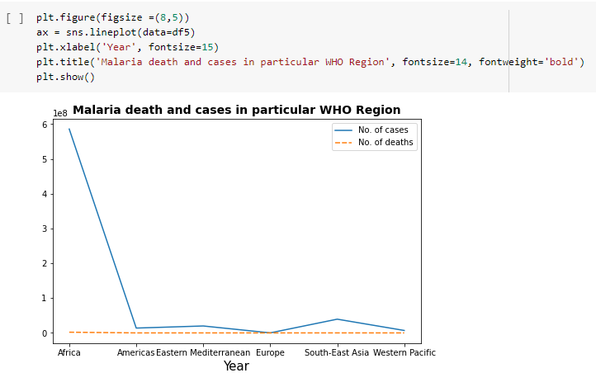

**FITTING REGRESSION LINE :**

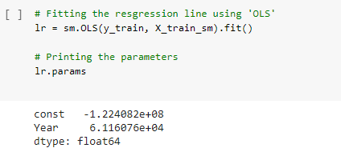

**SUMMARY OF THE REGRESSION LINE FITTED:**

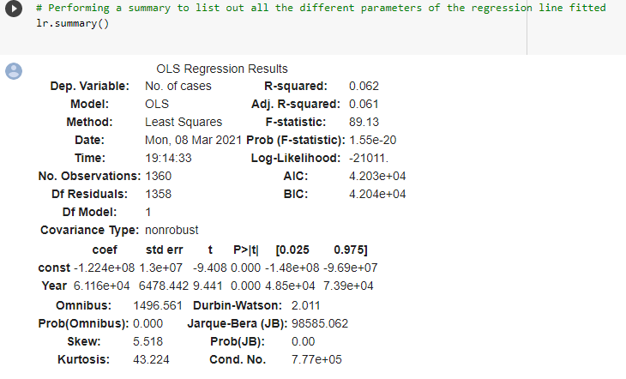

**VISUALIZATION OF REGRESSION LINE :**

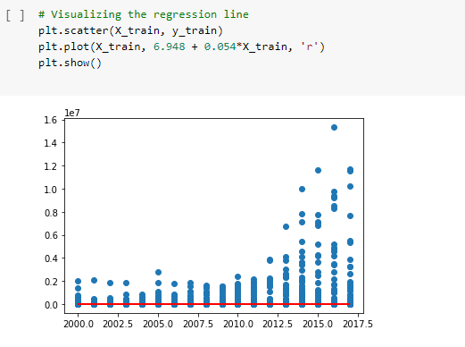

**R – SQUARED VALUE :**

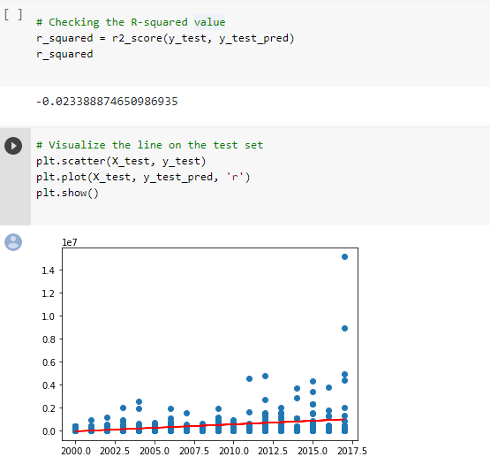

INTERPREDICTING THE RESULTS :

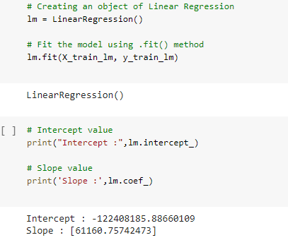

PREDICTING THE R2 SCORE :

